Model  Summer (JJA) | Historical Simulation | SSP245 | SSP585
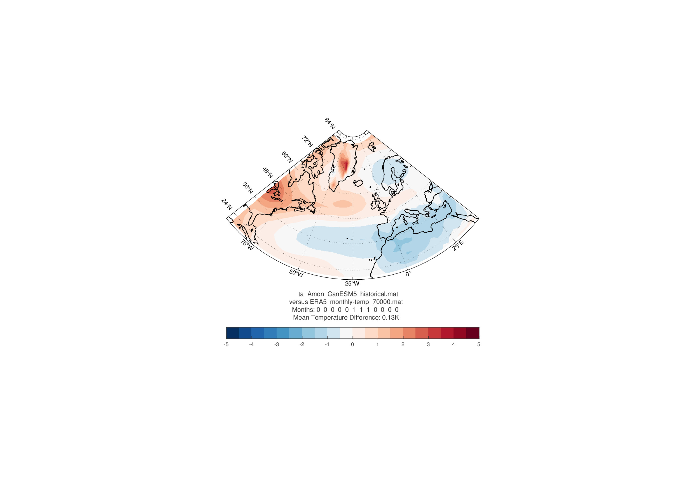
CanESM2
CESM2 | 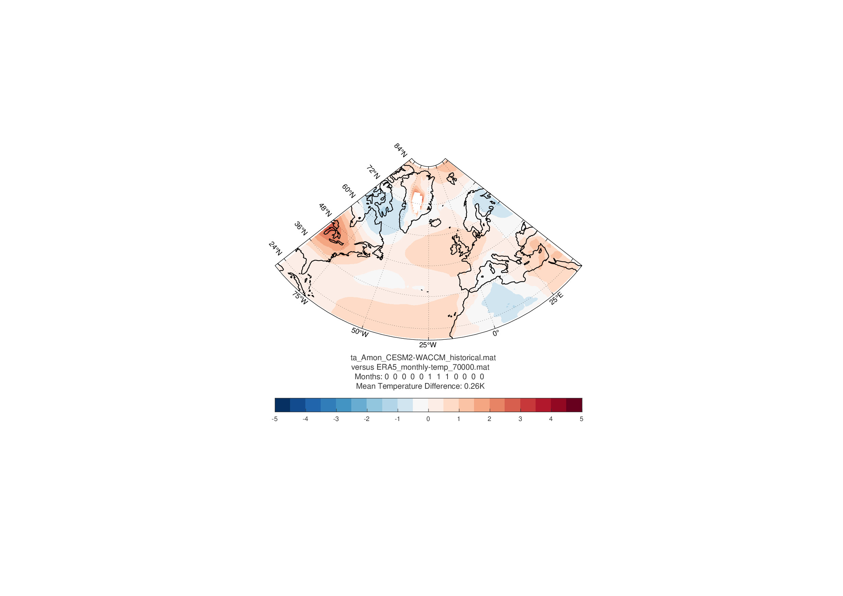
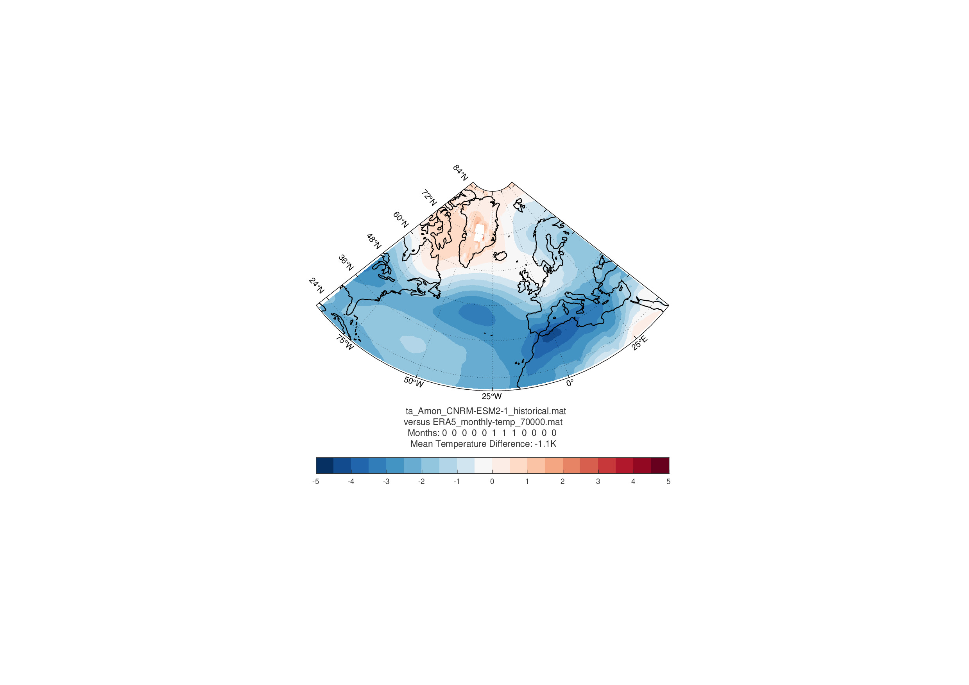
CNRM-CM5
EC Earth3 | 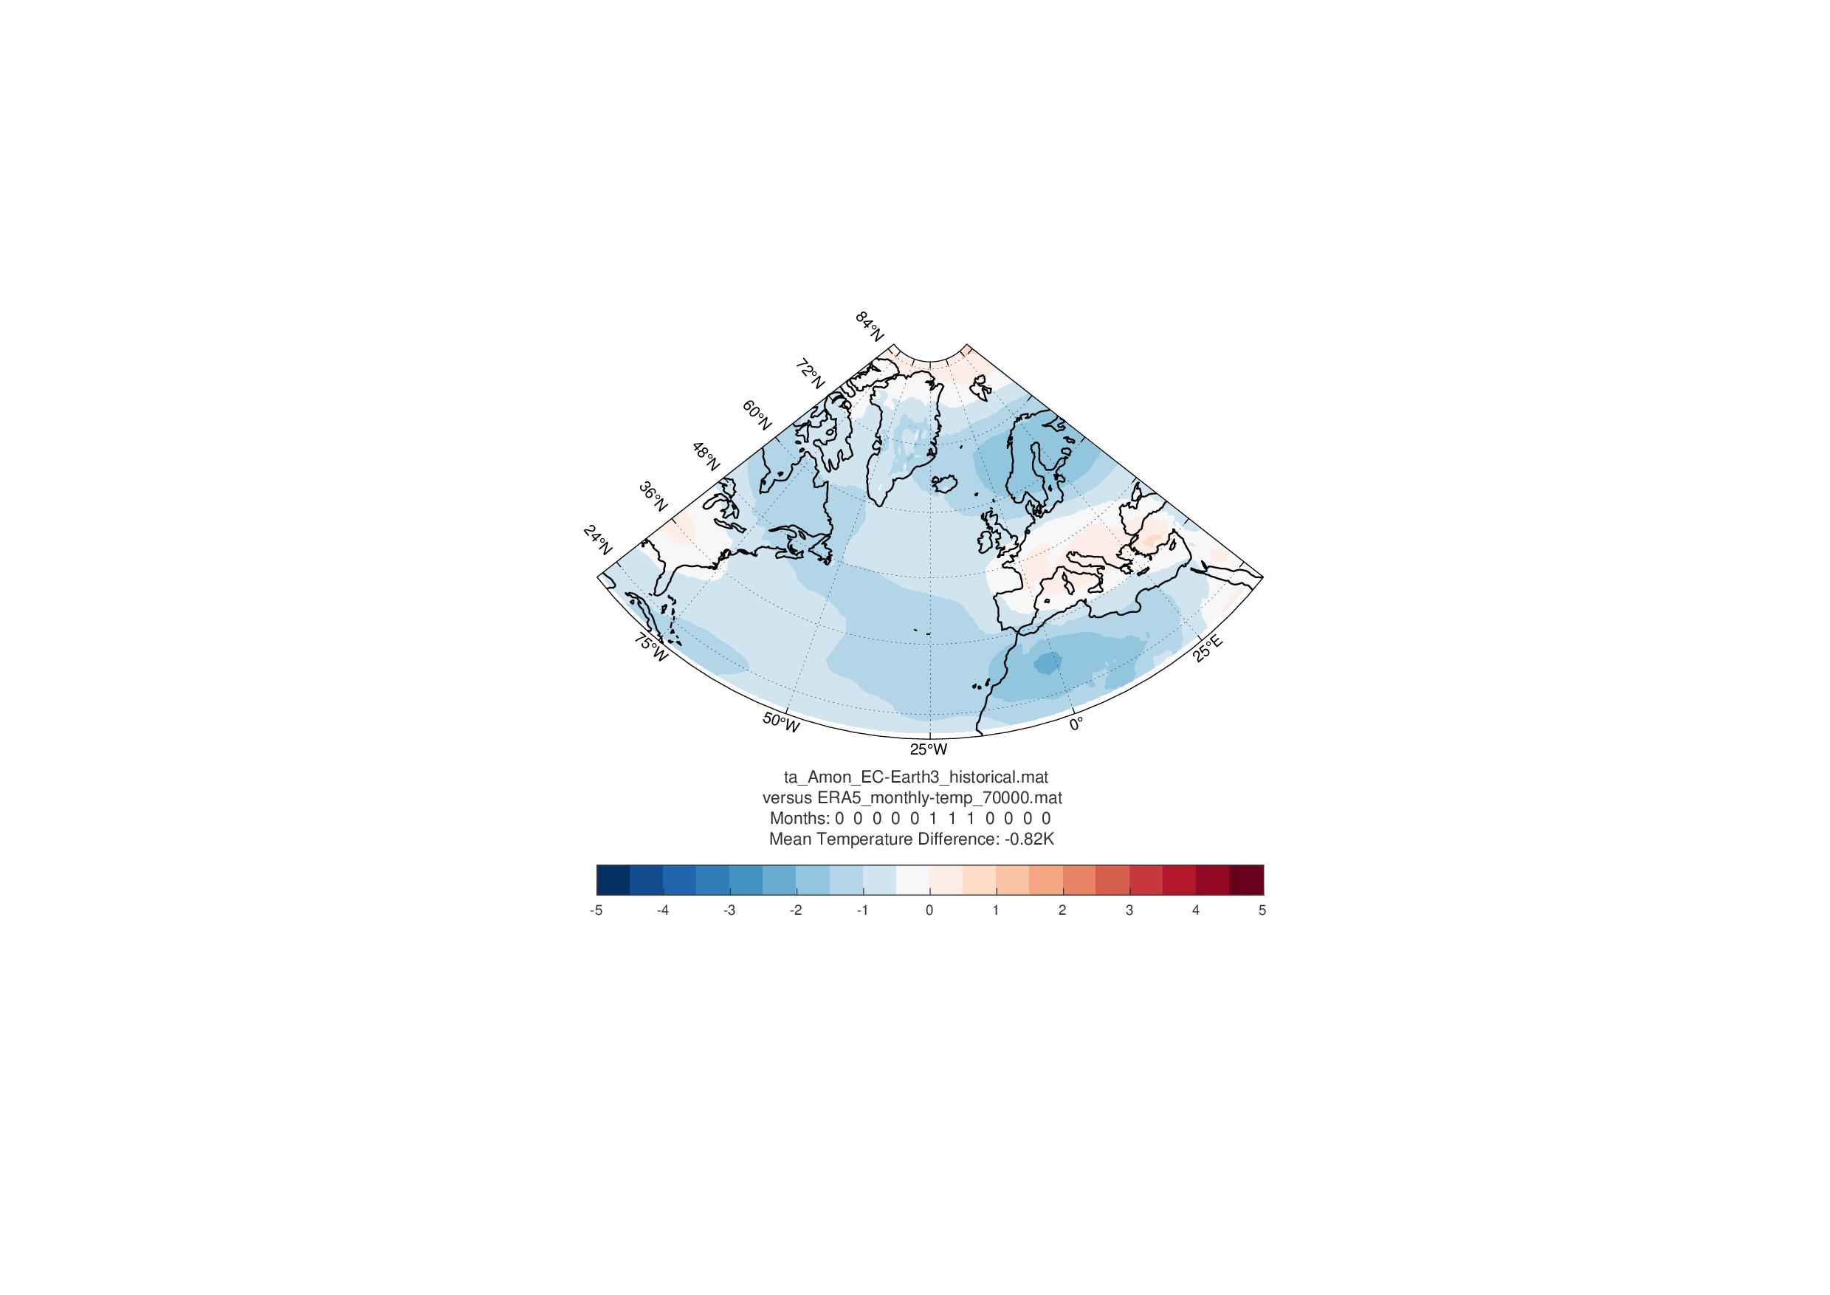

Summer (JJA)
Model | Historical Simulation | SSP245 | SSP585
IPSL-CM6 | 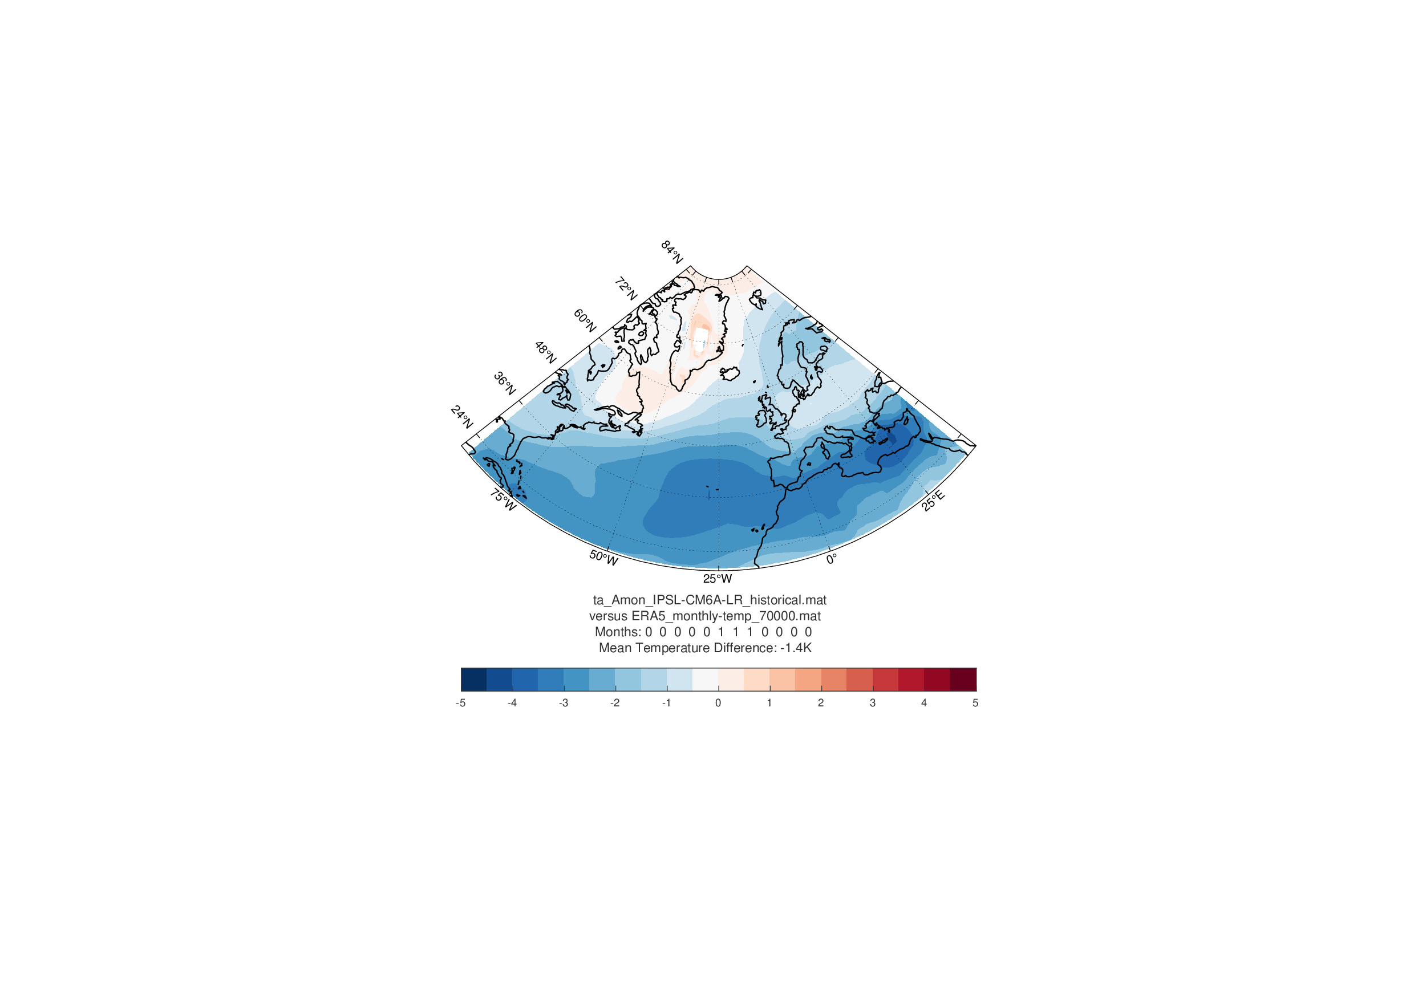  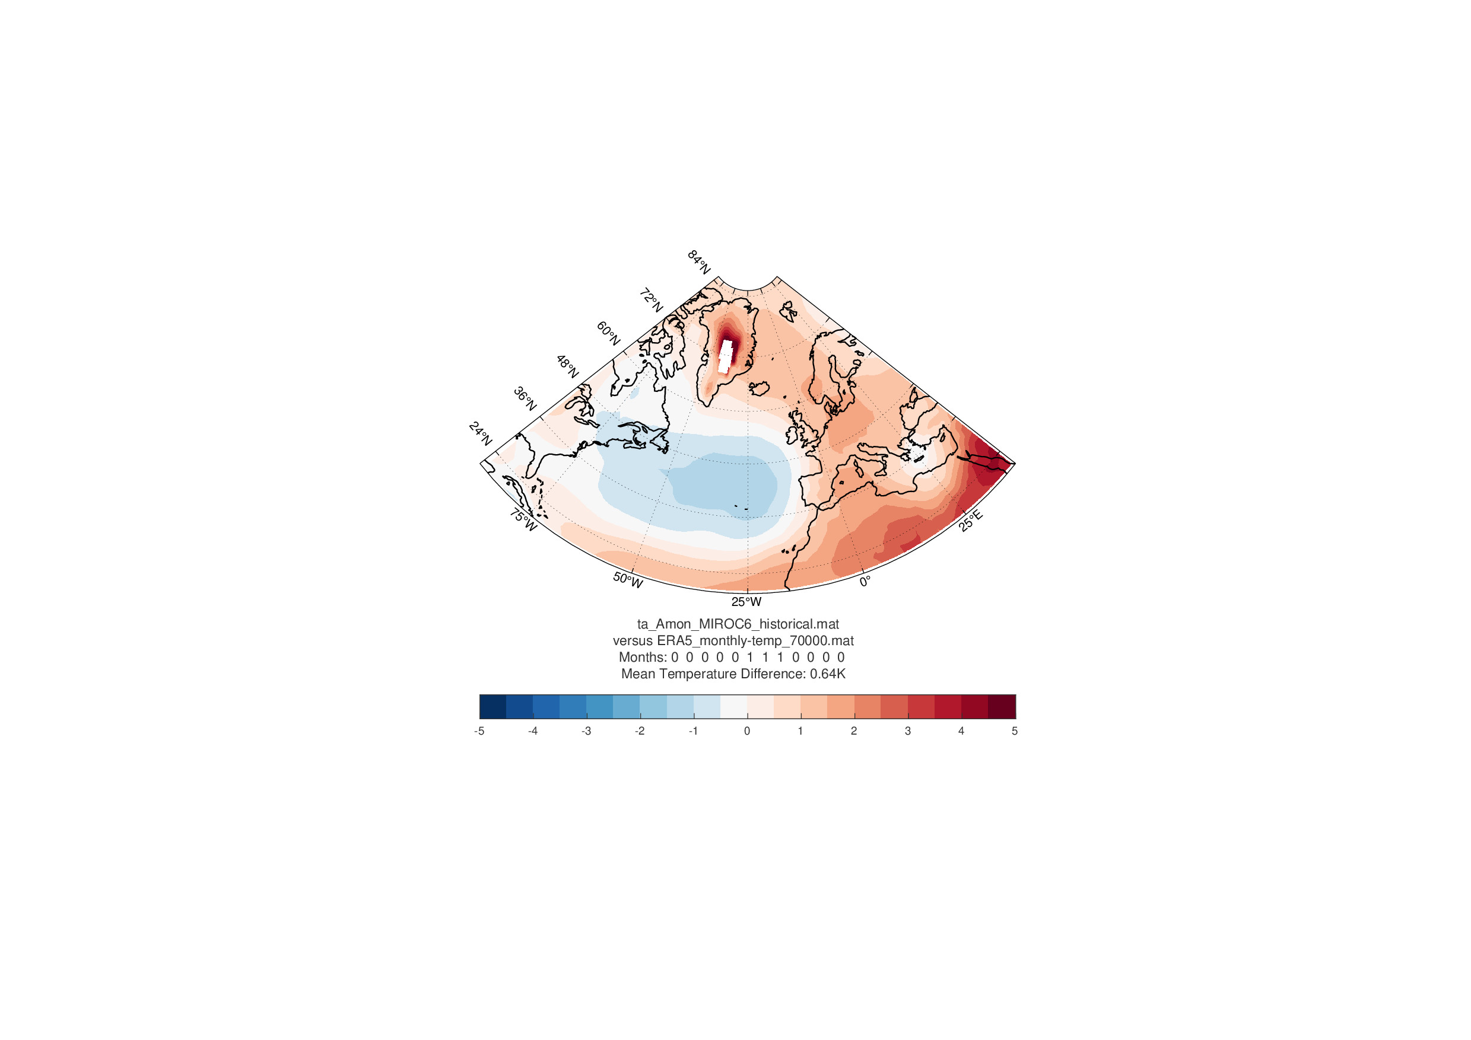
MIROC6
MRI-ESM2 | 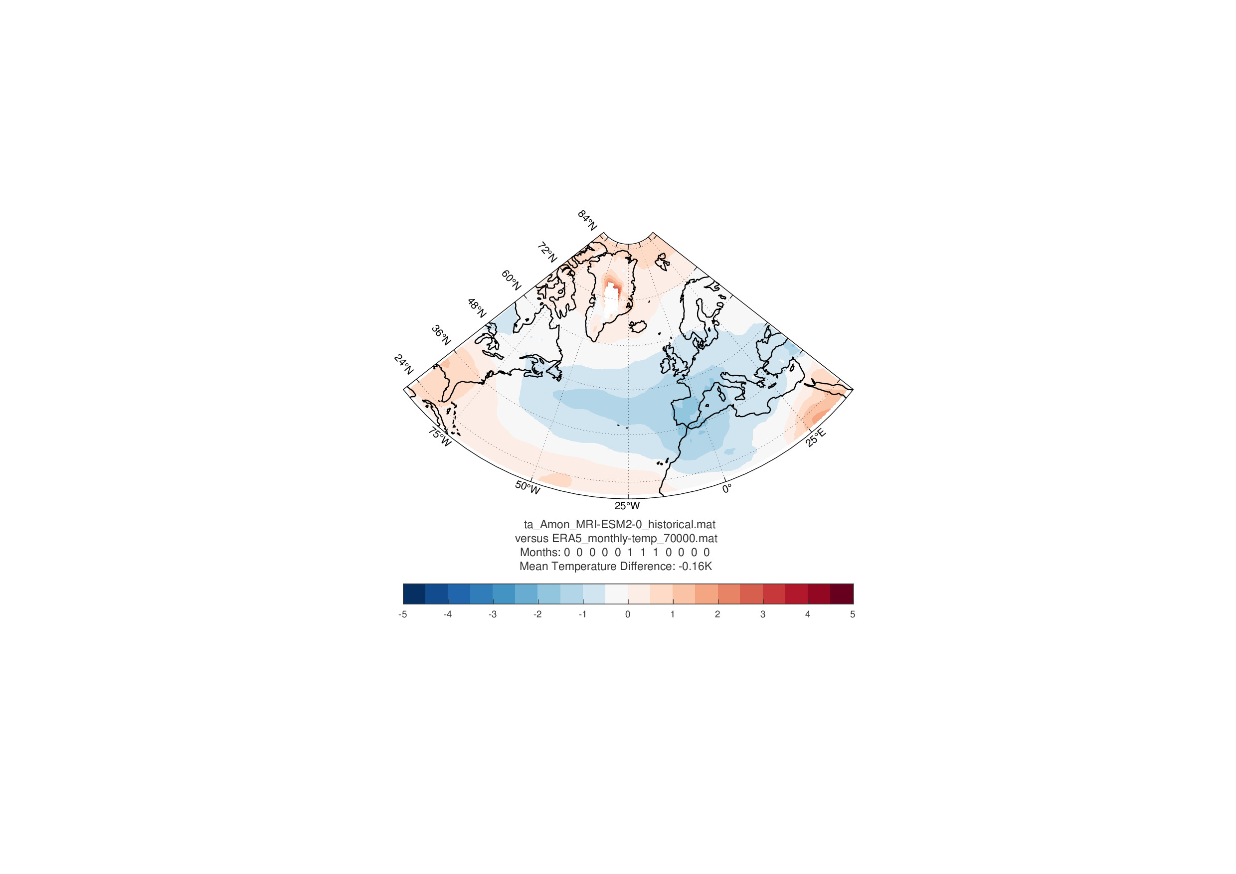  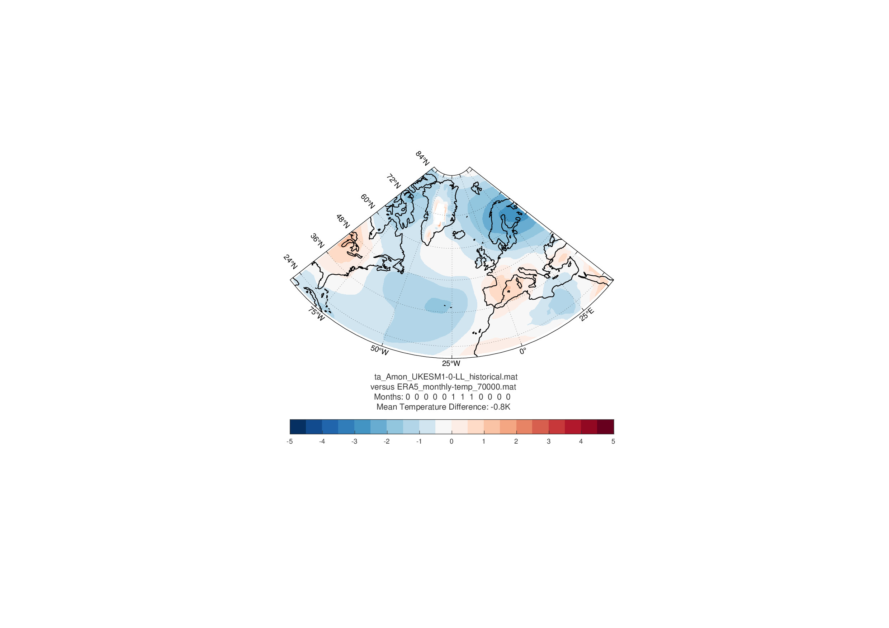
UKESM1

Model  Winter (DJF) | Historical Simulation | SSP245 | SSP585
CanESM2 | 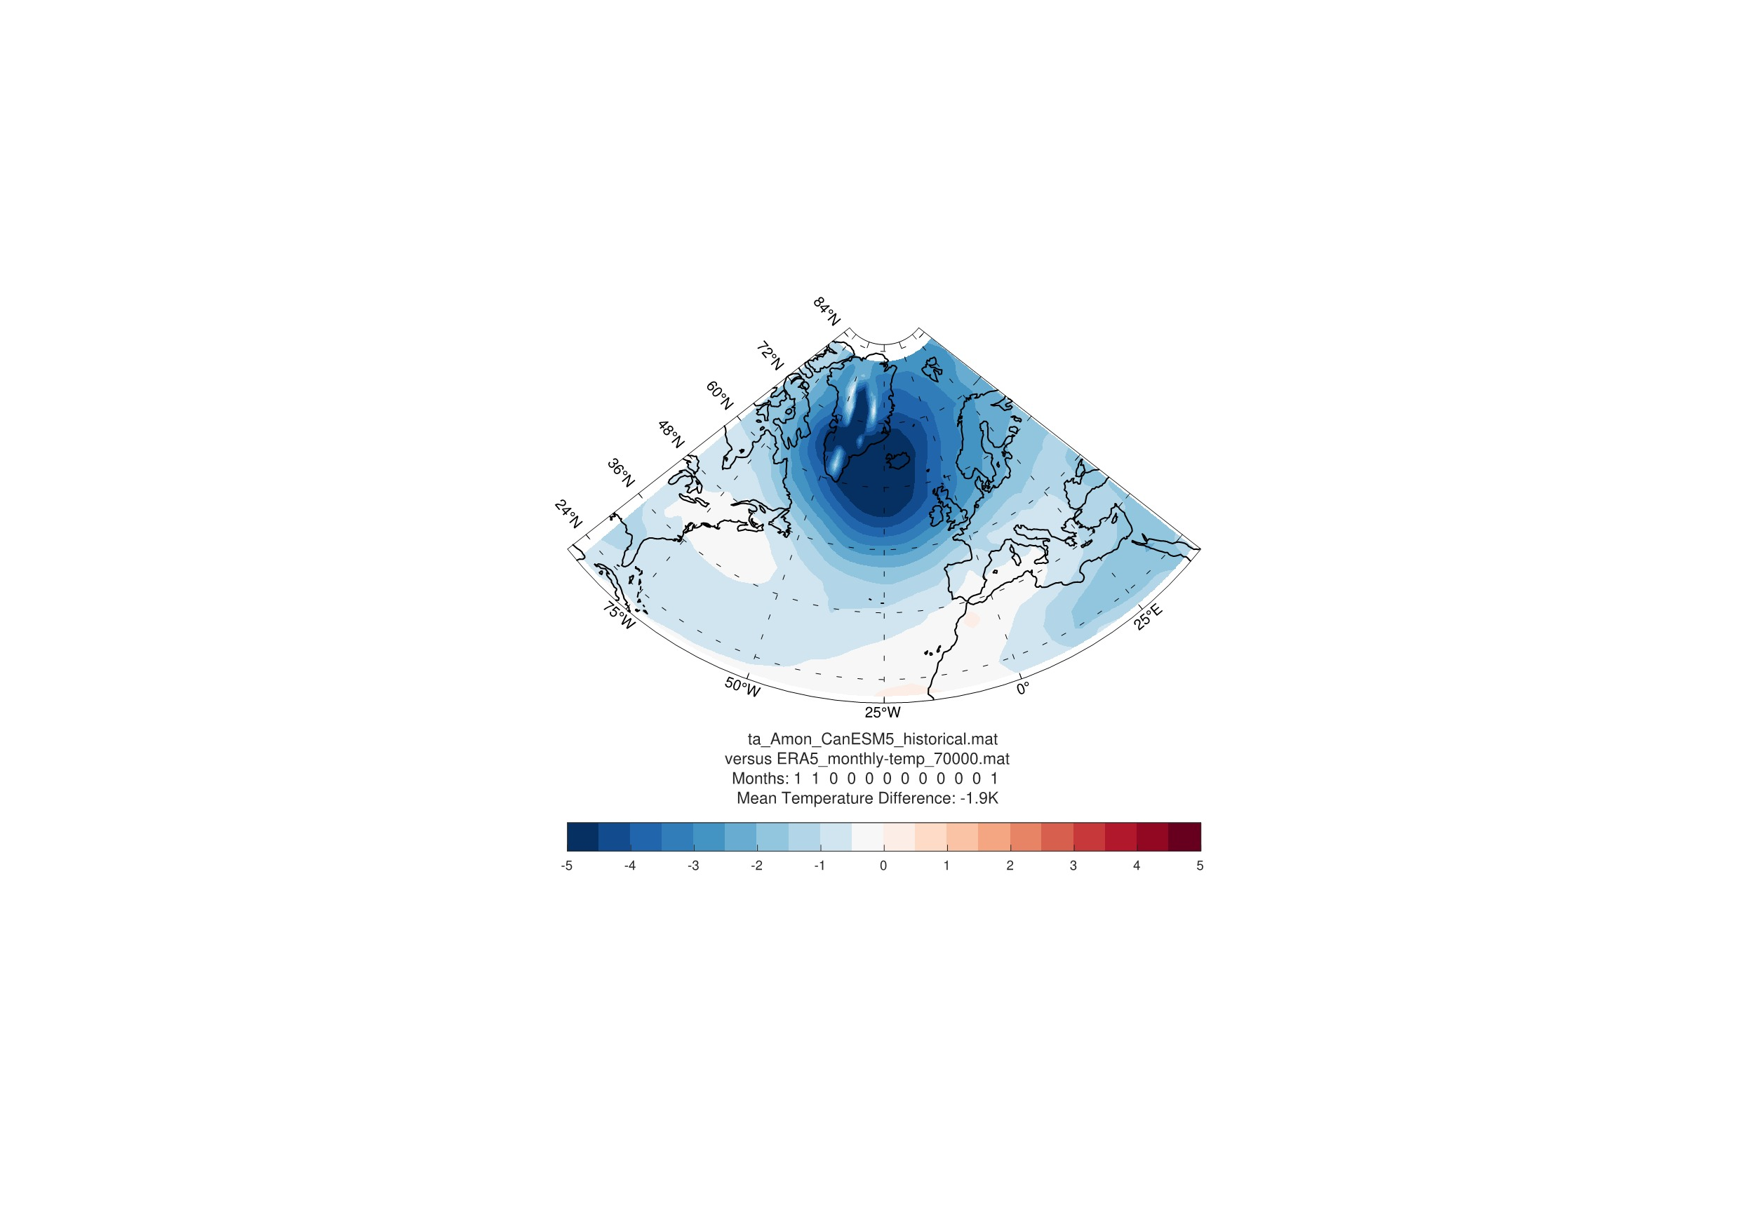
CESM2 | 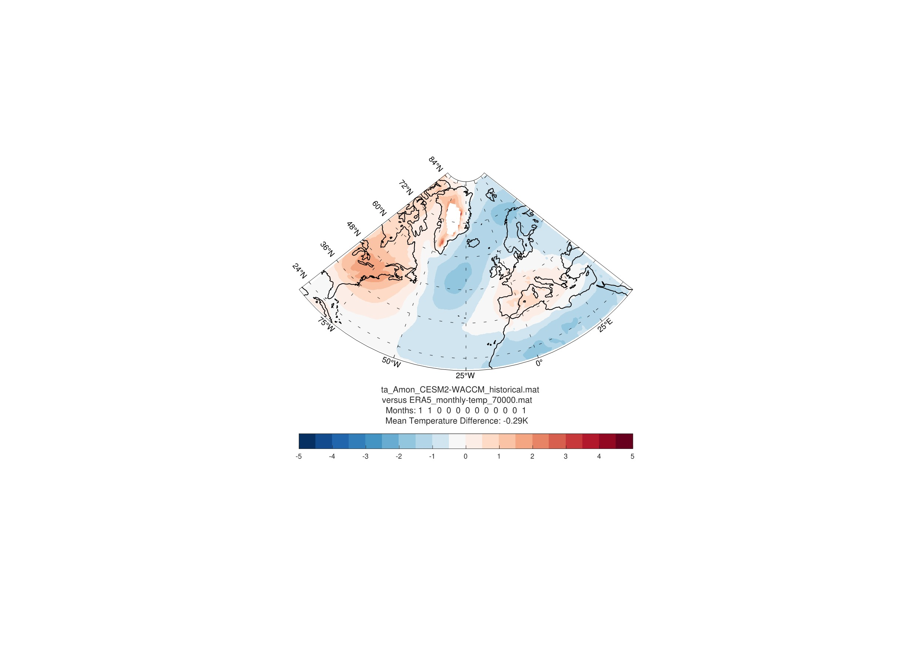
CNRM-CM5 | 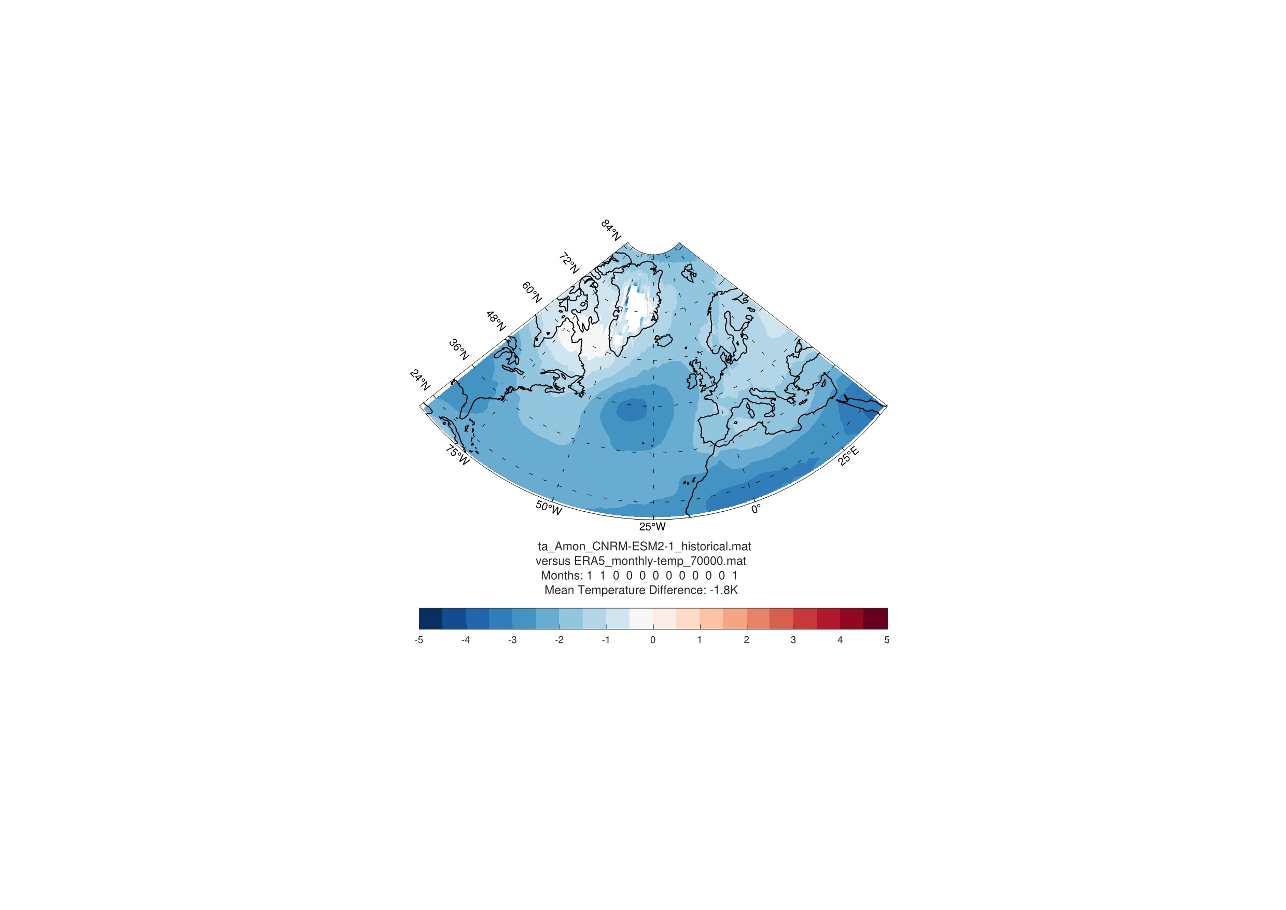  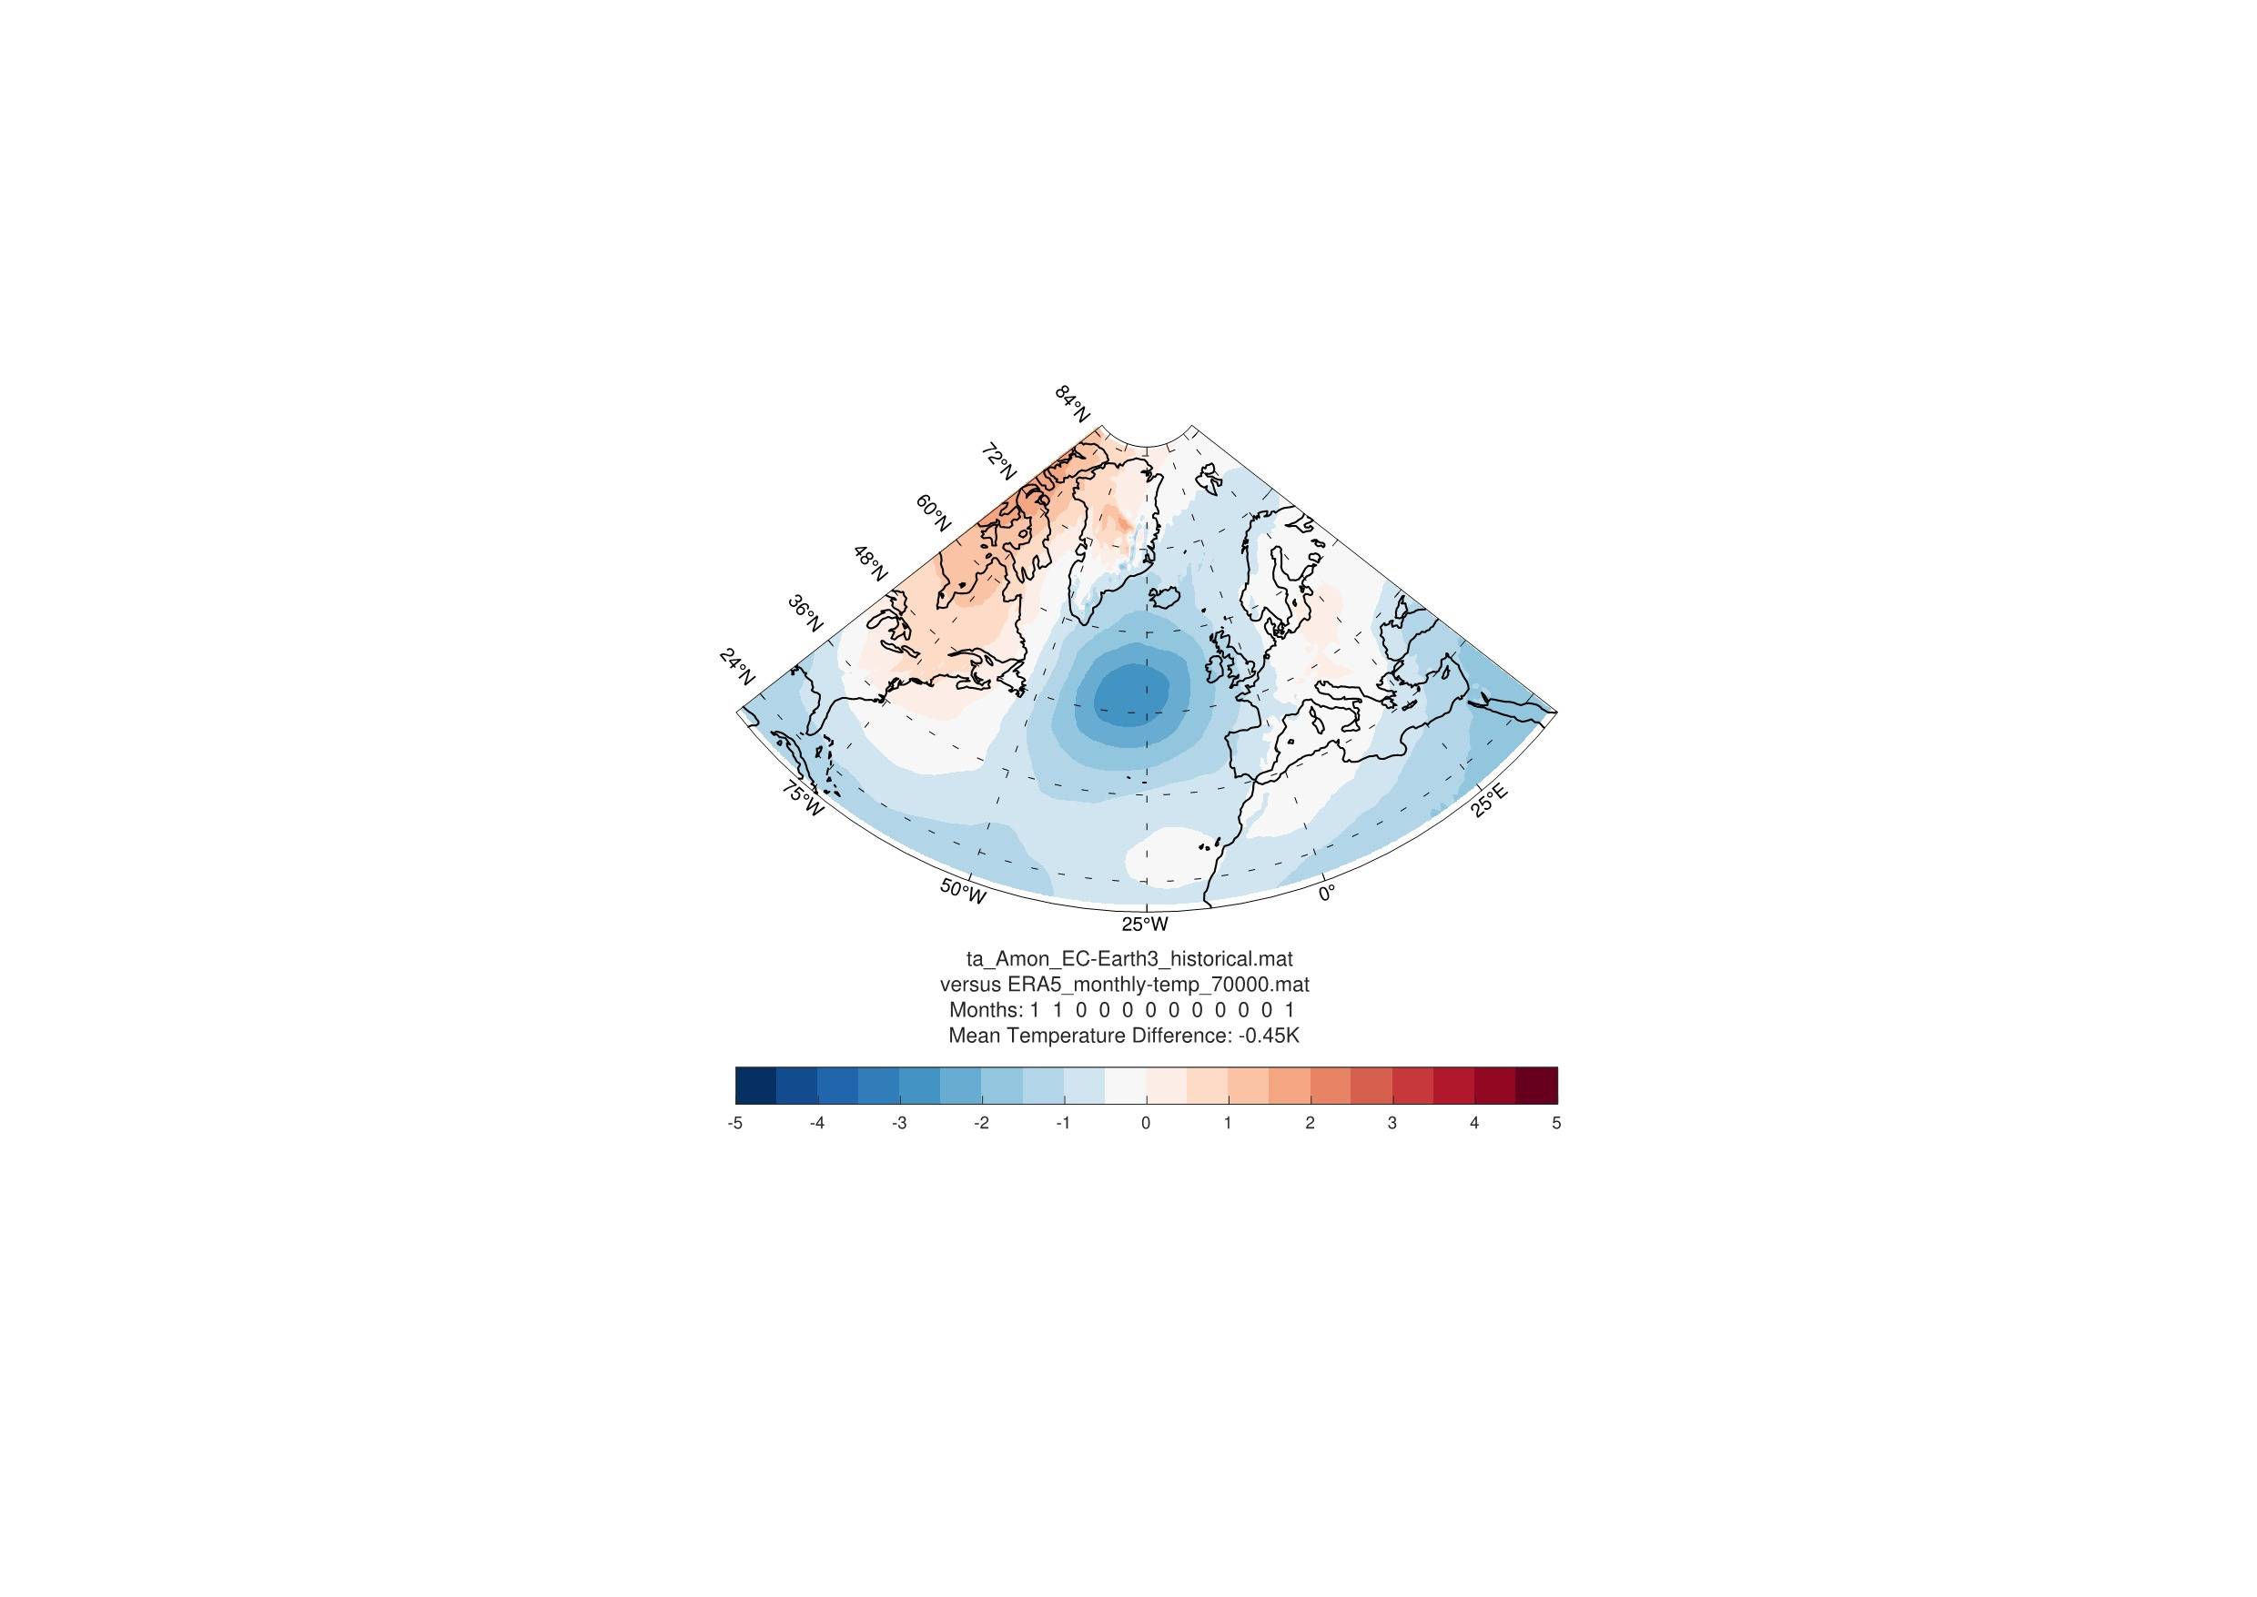
EC Earth3

Model | Historical Simulation | SSP245 | SSP585
IPSL-CM6 | 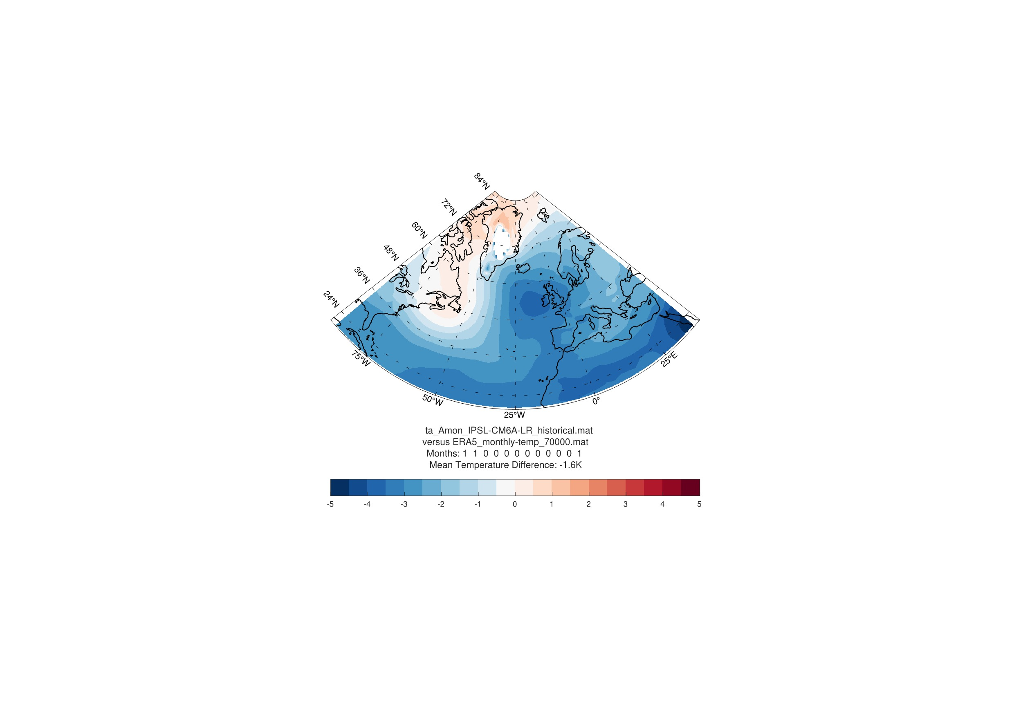
MIROC6 | 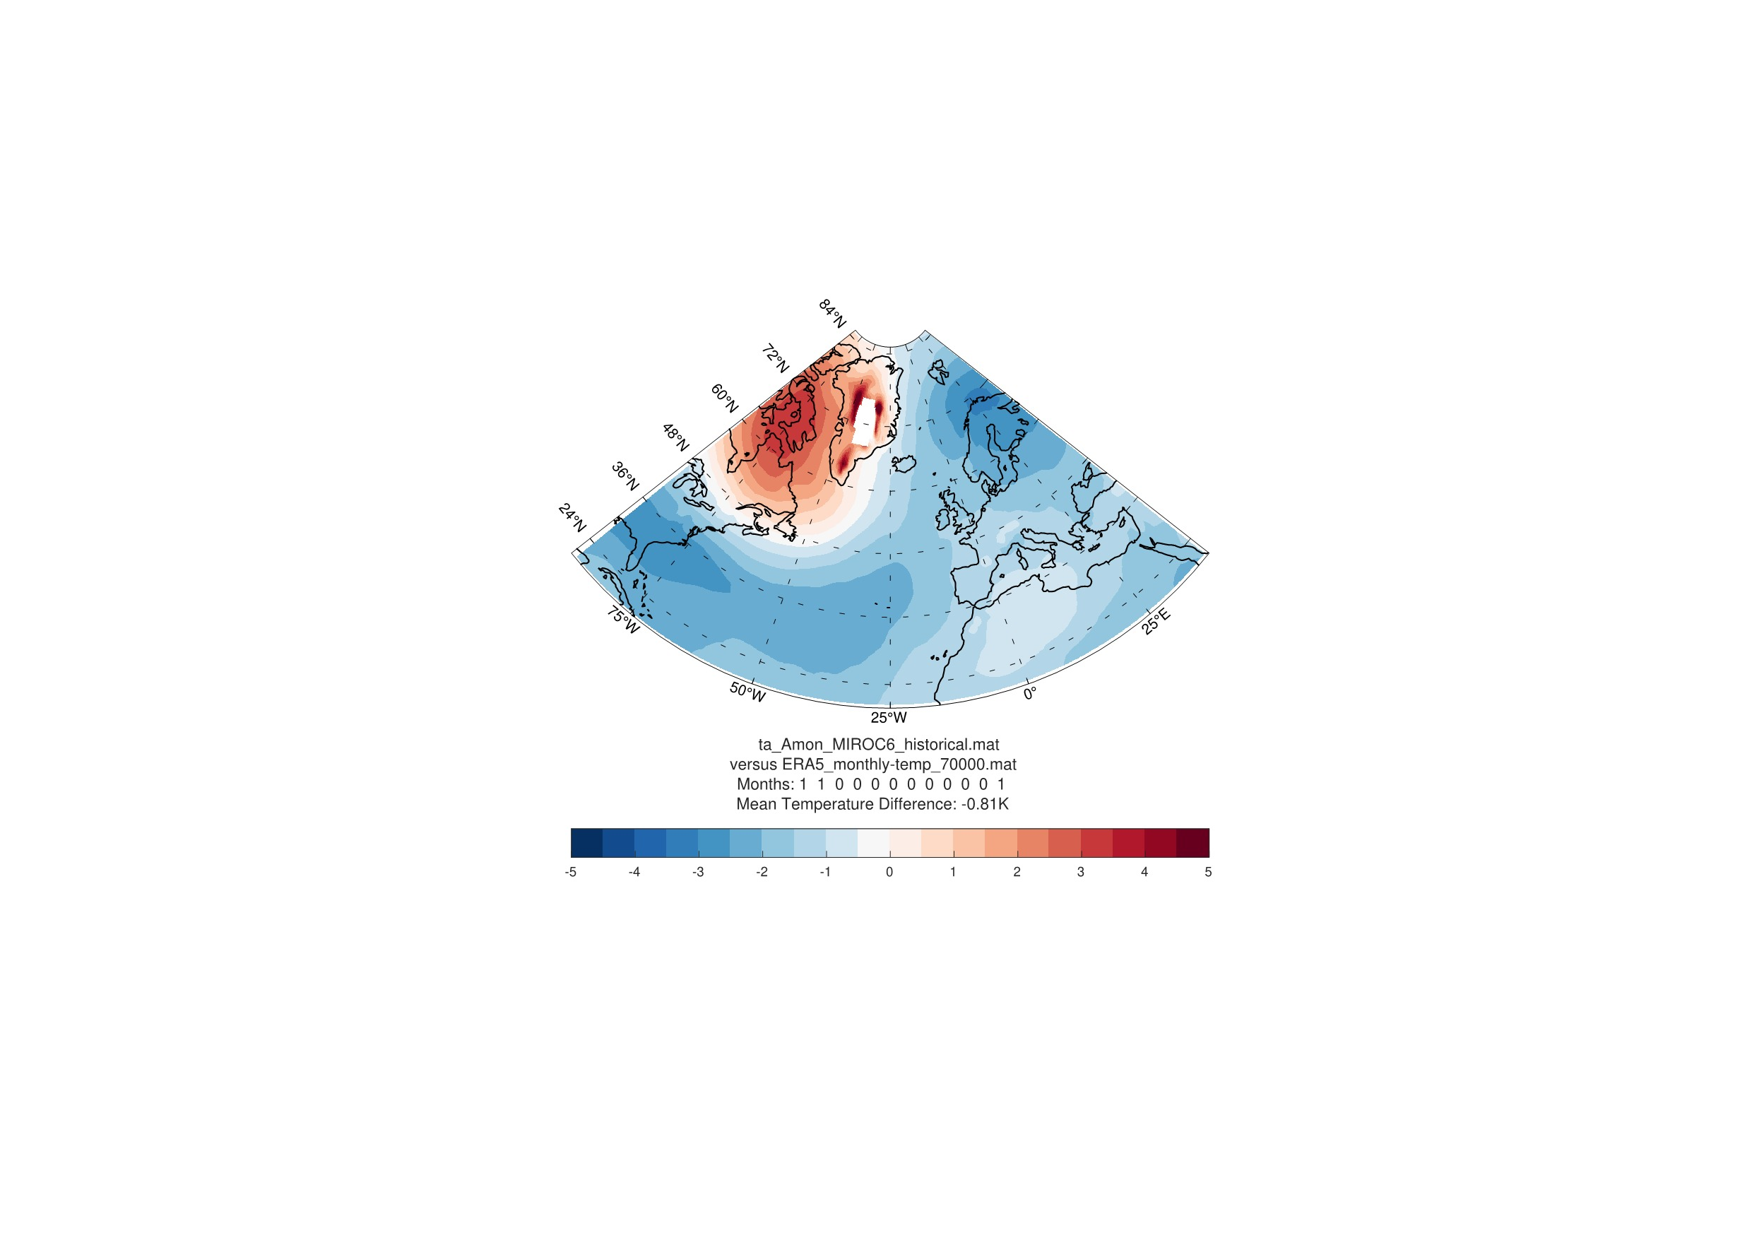  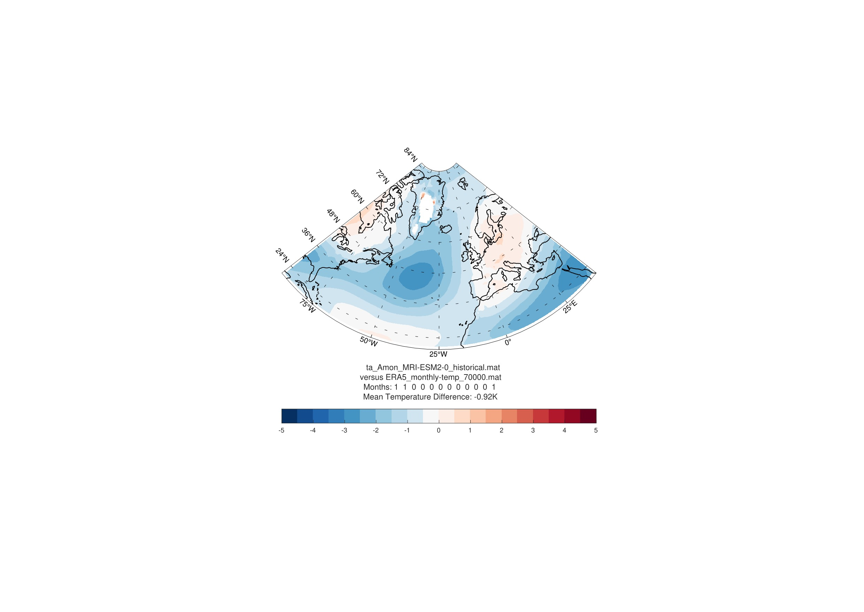
MRI-ESM2
UKESM1 | 